Chris Colella

Operating Systems

Prof Yikang

10/18/2022

Q1.Part 1

First, I started by researching proc files and the syntax behind the implementation. I used the following sources to figure out the syntax: Youtube videos, w3schools, thegeekstuff, and stackoverflow.

My program is broken up into 3 pieces.

Getting the jiffies

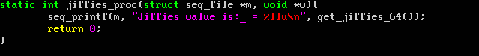

Module initialization, creating the proc file named “jiffies”, with normal permissions (0) and no parent (NULL).

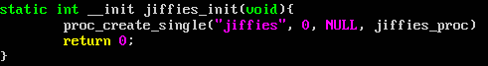

Module remover, removing the module when requested.



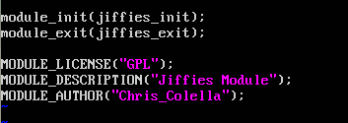

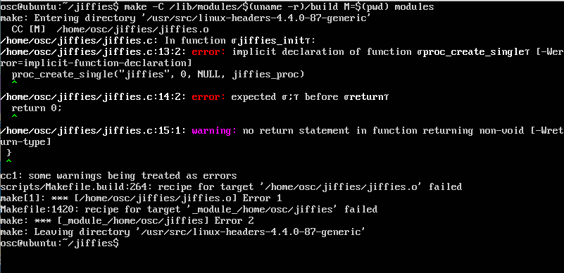Upon trying to make my jiffies module, I receive the following error message:

I tried rewriting the functions, double checking syntax, editing the Makefile to ignore warnings, and to stop seeing warnings as errors. And still I could not get the module to make.

Q1.Part 2

For this module, I roughly reused the code structure from my previous module file. Instead, this module will also have an equation to convert jiffies into seconds, and then be printed when initialized as a module.

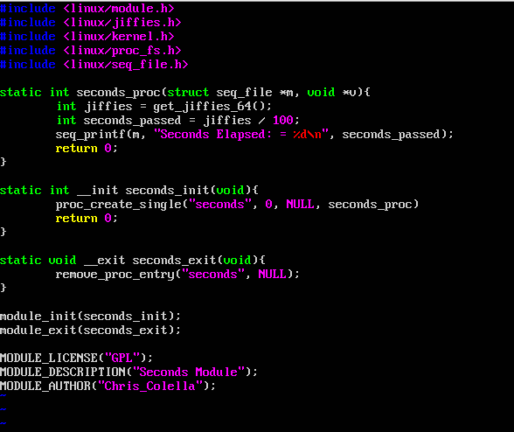Unfortunately I ran into a similar error that occurred with the first part. So I was not able to fully test and play with what I wrote attempting to convert jiffies to seconds. Regardless, here is what I was thinking about.

Like I mentioned, it has almost the same structure as my previous module. And that’s most likely why I’m still getting the same error.

I’m not 100% confident in the way I’m attempting to calculate the jiffies, but without being able to actually make this module and test it, this is all I can do.

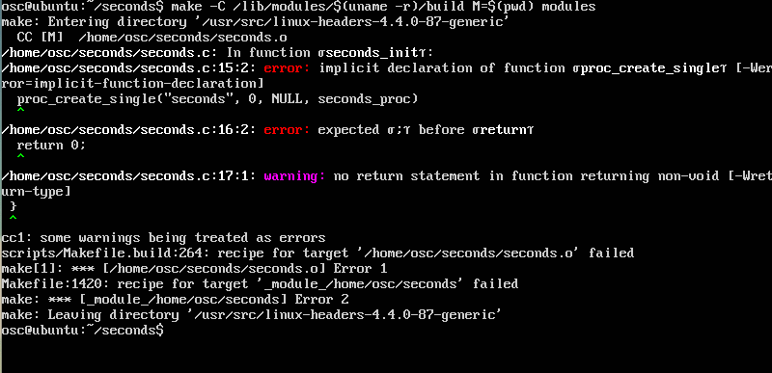For reference, this is the error message:

As for Q2, I simply did not have enough time between other class assignments and work to be able to solidly work and digest the problem.